Wh-questions
The task is introduced as a game in which the child participant (or the adult) will see pictures with one of the characters hidden. The child pretends to play with a puppet that has been introduced to the child and who always knows everything. The child is invited to ask the puppet a question. The puppet answer and the hidden character is revealed. The child has to say whether the puppet was right or not.
All picture descriptions and questions are recorded previously and implemented into Labvanced to guarantee the controlled factors.
For each language, two different voices need to be recorded, one as the narrator for the picture descriptions and the other as the puppet who answers the child’s questions. This can be done by inviting two native speakers to complete the recording or alternatively by one single person changing his/her voice so that the mouse’s voice sounds different from the plain voice. For data protection reasons, the person whose voice will be recorded needs to sign a document stating that they grant us the use of their voice in our stimuli and agree to share the record for the purpose of the experiment. We will provide you with this document.

Phase 0: Introduction
Present puppet in Labvanced
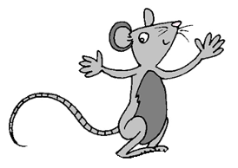
Audio - Narrator's voice:
- “This is Puffi. All people/everyone says that Puffi has a nice voice. Puffi can you make us hear it?” (YOU CAN CHANGE THE NAME WITH ONE THAT IS APPROPRIATE IN YOUR LANGUAGE)!”
Audio - Puffi’s voice:
- “Sure. Do you like my voice?”
Audio - Narrator's voice:
- “Now we are going to make a game. I will show some pictures, with someone hidden. Puffi always knows everything. So you will ask Puffi about the hidden character. Let’s see how it works.”

Phase 1: Warm up (3 sentences, not randomized)
WU1
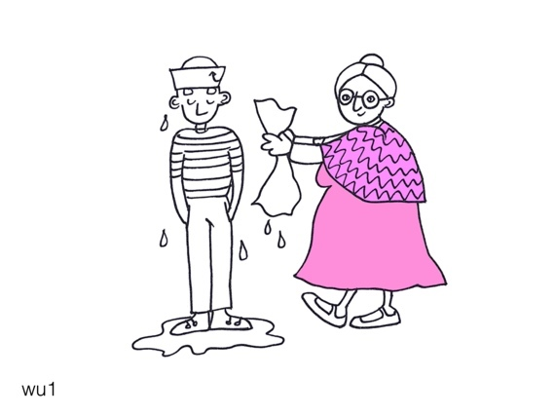(lady covered)
Audio - Narrator:
- “Someone is wetting the sailor. The puppet knows who. Ask the puppet (who).” (who must not be used in Mandarin or language in which you have to say “is who”)
Recording:
*CHI: “Who is wetting the sailor?”*

Audio - Puppet (always at a corner of the screen):
- “A lady.”

Reveal the character
Audio - Narrator:
- “Good Puffi!”

WU2
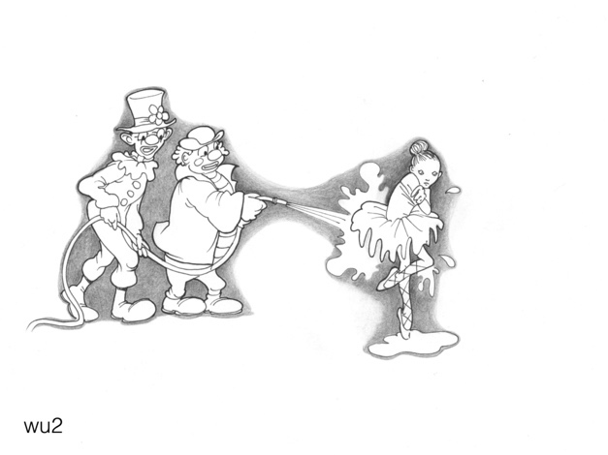(clowns covered)
Narrator:
- “Someone is washing the dancer. The puppet knows who. Ask the puppet (who).”
*CHI: “Who is washing the dancer?”*
Puppet:
- “Two clowns.”

Reveal the character
Narrator:
- “Good Puffi!”

WU3
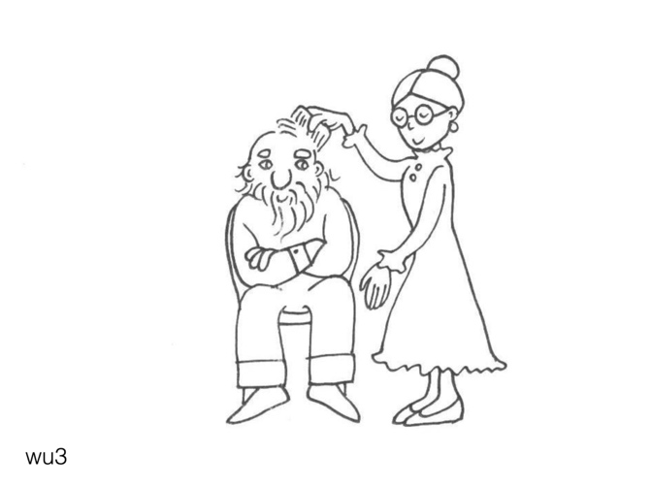(lady covered)
Narrator:
- “Someone is combing the old man. The puppet knows who. Ask the puppet (who).”
*CHI: “Who is combing the man?”
Puppet:
- “A lady.”
Reveal the character
Narrator:
- “Good Puffi!”

Phase 2: Experiment – Who (12 sentences, 6 subject + 6 object, randomized)
S1
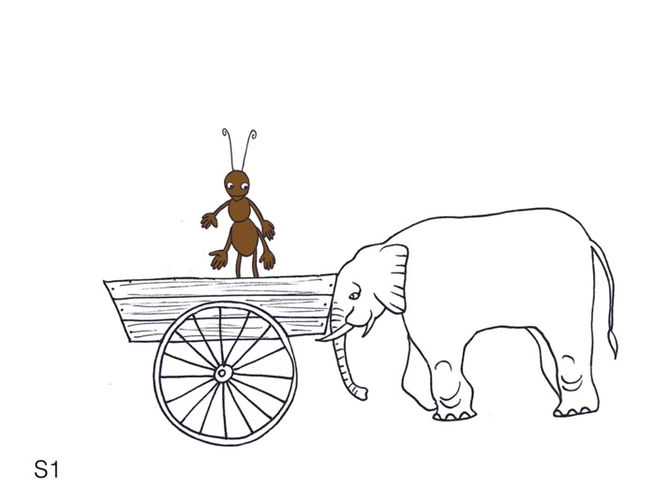(elephant covered)
Narrator:
- “Someone is pushing the ant. The puppet knows who. Ask the puppet (who).”
*CHI: “Who is pushing the ant?”
Puppet:
- “An elephant.”
Reveal the character
Narrator:
- “Good Puffi!”

S2
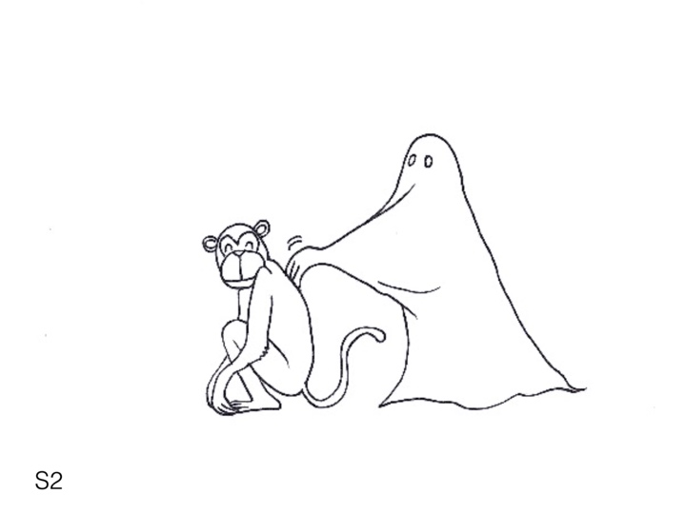(ghost covered)
Narrator:
- “Someone is scratching the monkey. The puppet knows who. Ask the puppet (who).”
*CHI: “Who is scratching the monkey?”
Puppet:
- “A ghost.”
Reveal the character
Narrator:
- “Good Puffi!”

S3
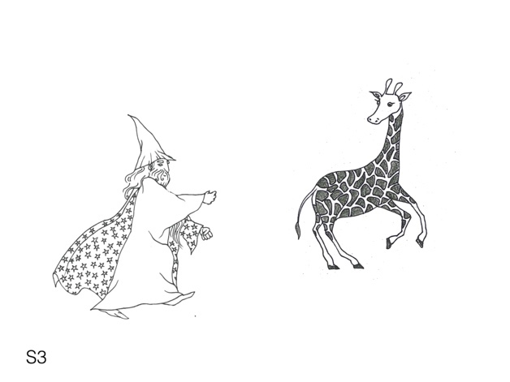(witch covered)
Narrator:
- “Someone is chasing the giraffe. The puppet knows who. Ask the puppet (who).”
*CHI: “Who is chasing the giraffe?”
Puppet:
- “A witch.”
Reveal the character
Narrator:
- “Good Puffi!”

S4
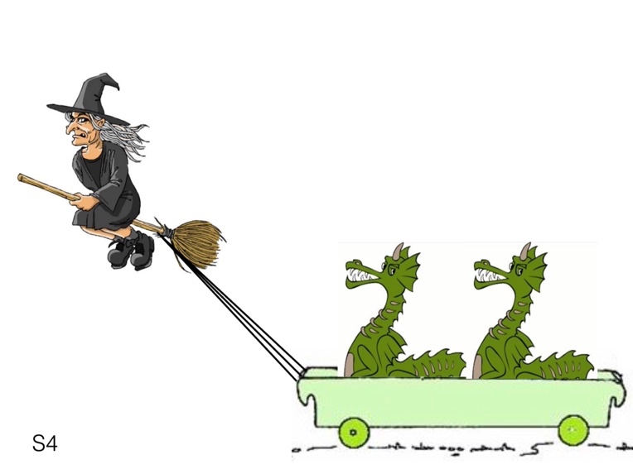(witch covered)
Narrator:
- “Someone is pulling the dragon. The puppet knows who. Ask the puppet (who).”
*CHI: “Who is pulling the dragon?”
Puppet:
- “A witch.”
Reveal the character
Narrator:
- “Good Puffi!”

S5
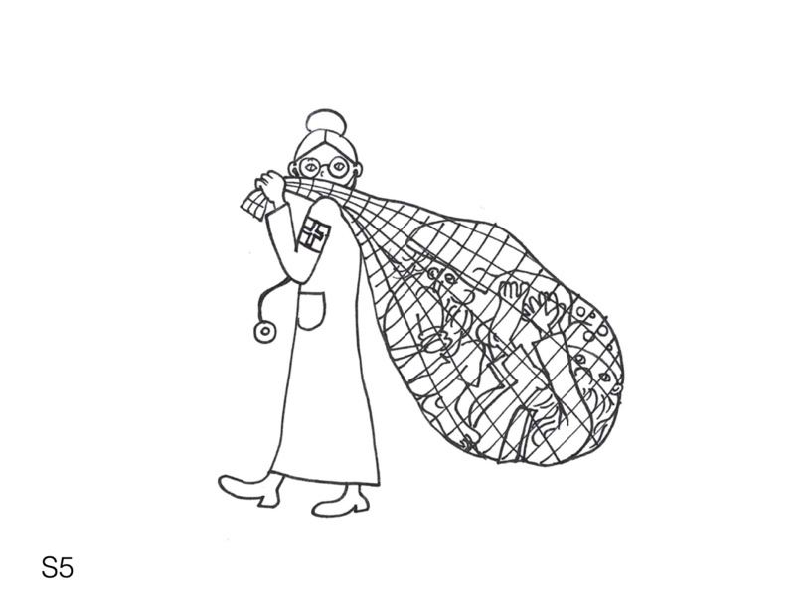(lady covered)
Narrator:
- “Someone is carrying the dwarf. The puppet knows who. Ask the puppet (who).”
*CHI: “Who is carrying the dwarf?”
Puppet:
- “A lady.”
Reveal the character
Narrator:
- “Good Puffi!”

S6
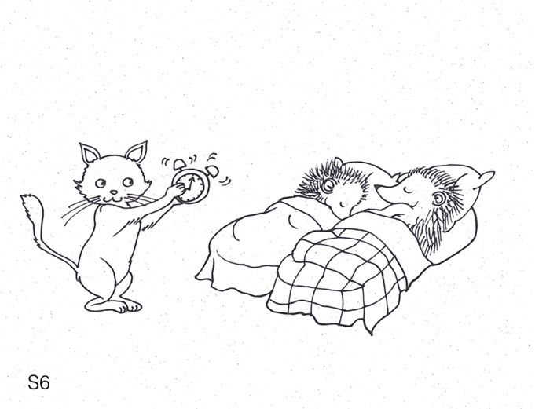(cat covered)
Narrator:
- “Someone is waking the hedgehogs. The puppet knows who. Ask the puppet (who).”
*CHI: “Who is waking the hedgehogs?”
Puppet:
- “A cat.”
Reveal the character
Narrator:
- “Good Puffi!”

O1
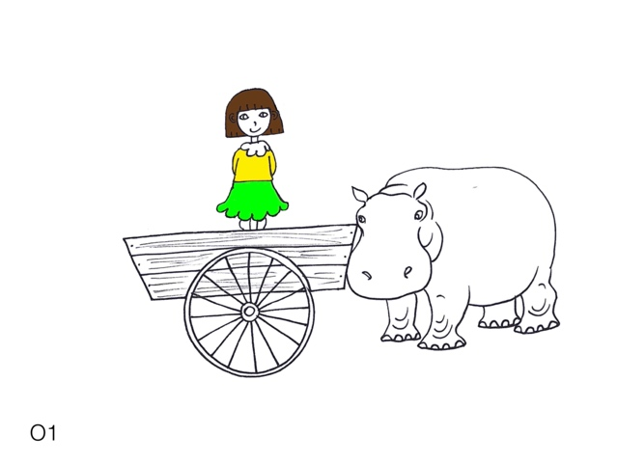(girl covered)
Narrator:
- “The hippo is pushing someone. The puppet knows who. Ask the puppet (who).”
*CHI: “Who is the hippo pushing?”
Puppet:
- “A girl.”
Reveal the character
Narrator:
- “Good Puffi!”

O2
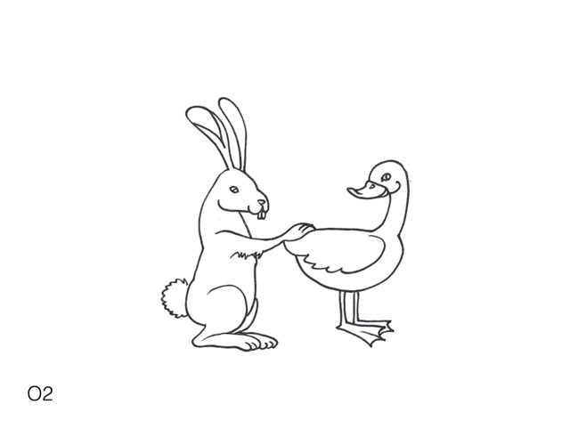(duck covered)
Narrator:
- “The rabbit is scratching someone. The puppet knows who. Ask the puppet (who).”
*CHI: “Who is the rabbit scratching?”
Puppet:
- “A duck.”
Reveal the character
Narrator:
- “Good Puffi!”

O3
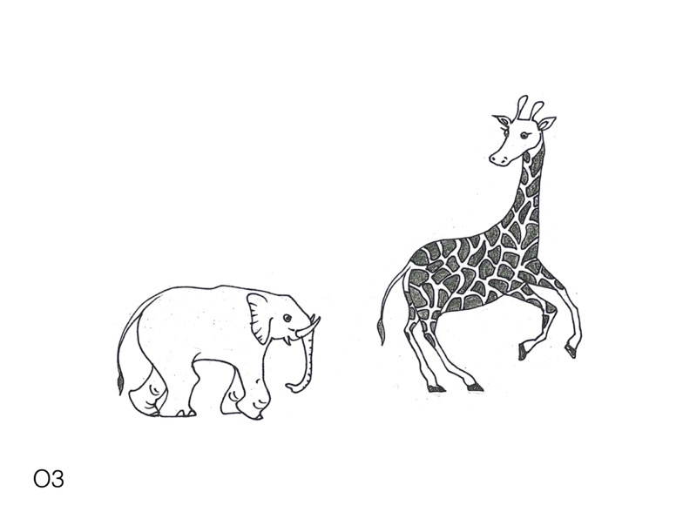(giraffe covered)
Narrator:
- “The elephant is chasing someone. The puppet knows who. Ask the puppet (who).”
*CHI: “Who is the elephant chasing?”
Puppet:
- “A giraffe.”
Reveal the character
Narrator:
- “Good Puffi!”

O4
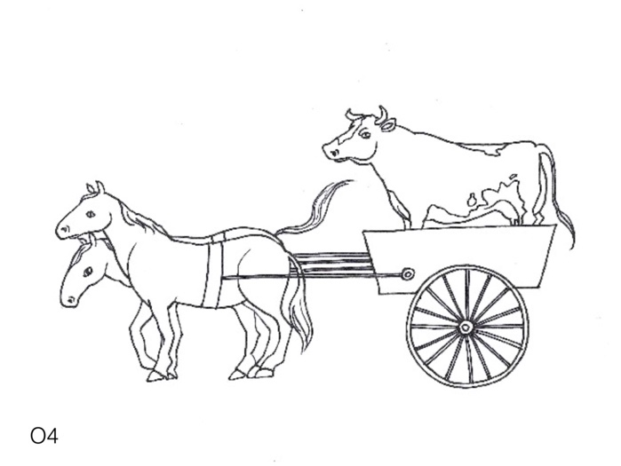(cow covered)
Narrator:
- “The horses are pulling someone. The puppet knows who. Ask the puppet (who).”
*CHI: “Who are the horses pulling?”
Puppet:
- “A cow.”
Reveal the character
Narrator:
- “Good Puffi!”

O5
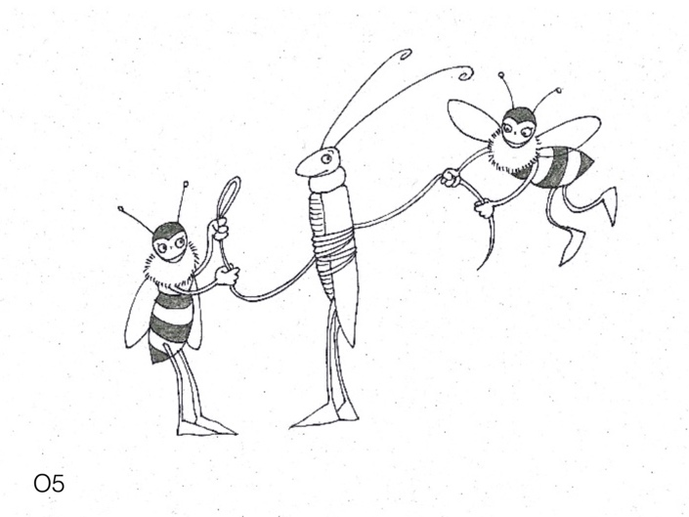(grasshopper covered)
Narrator:
- “The bees are catching someone. The puppet knows who. Ask the puppet (who).”
*CHI: “Who are the bees catching?”
Puppet:
- “A grasshopper.”
Reveal the character
Narrator:
- “Good Puffi!”

O6
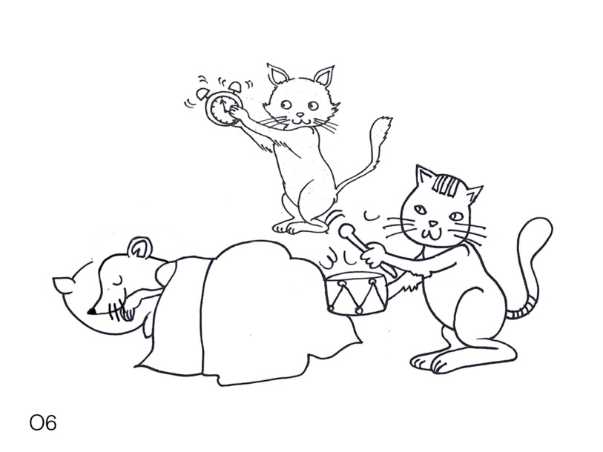(mouse covered)
Narrator:
- “The cats are waking up someone. The puppet knows who. Ask the puppet (who).”
*CHI: “Who are the cats waking up?”
Puppet:
- “A mouse.”
Reveal the character
Narrator:
- “Good Puffi!”

Phase 3: Experiment – Which (12 sentences, 6 subject + 6 object, randomized)
S7
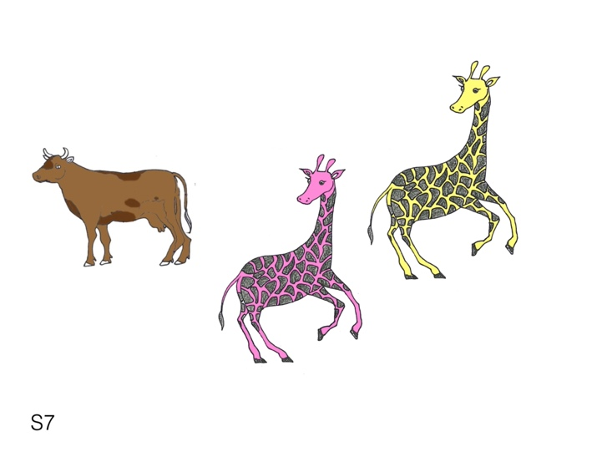
Narrator:
- “There is a cow and two giraffes, one is pink and the other is yellow. Let's see what happens.”
Change picture
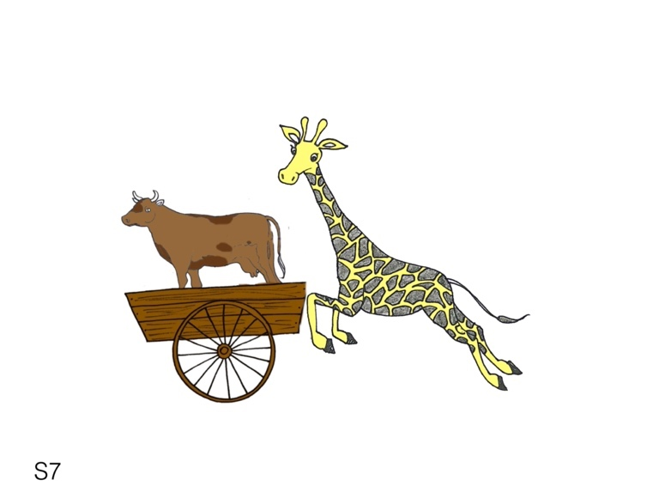(giraffe covered)
Narrator:
- “One of the giraffes is pushing the cow. The puppet knows which. Ask the puppet (which).
*CHI: “Which giraffe is pushing the cow?”
Puppet:
- “The yellow giraffe.”
Reveal the character
Narrator:
- “Good Puffi!”

S8
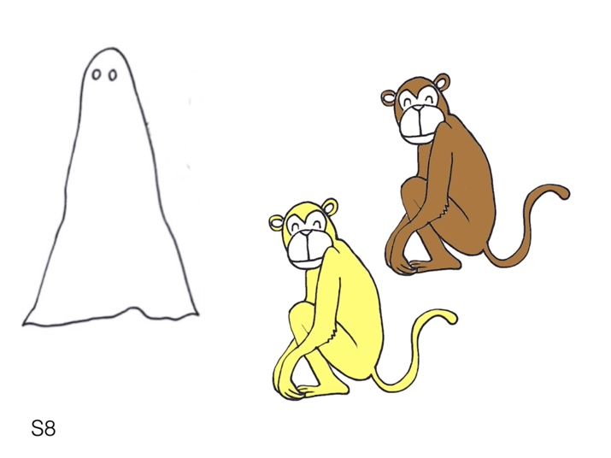
Narrator:
- “There is a ghost and two monkeys, one is yellow and the other is brown. Let's see what happens.”
Change picture
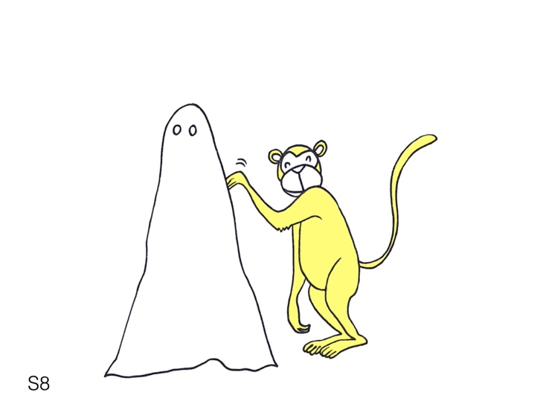(monkey covered)
Narrator:
- “One of the monkeys is scratching the ghost. The puppet knows which. Ask the puppet (which).
*CHI: “Which monkey is scratching the ghost?”
Puppet:
- “The yellow monkey.”
Reveal the character
Narrator:
- “Good Puffi!”

S9
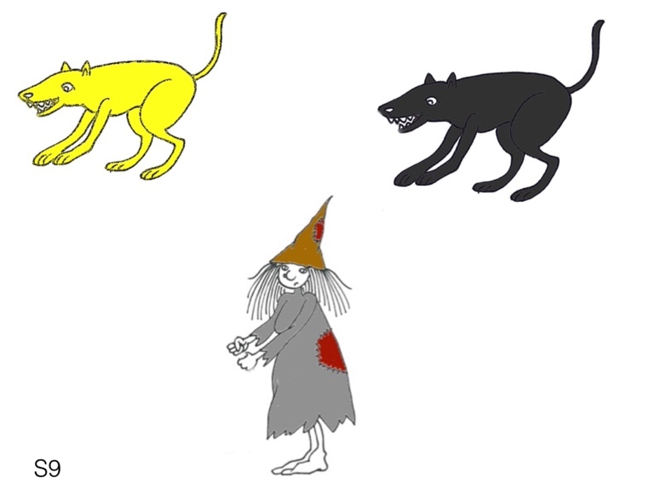
Narrator:
- “There is a witch and two dogs, one is yellow and the other is black. Let's see what happens.”
Change picture
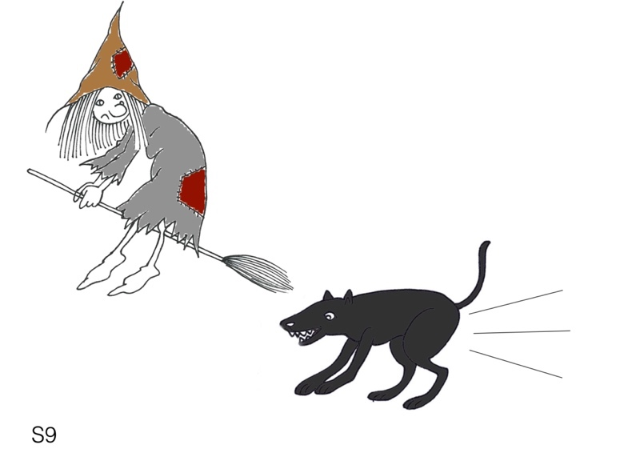(dog covered)
Narrator:
- “One of the dogs is chasing the witch. The puppet knows which. Ask the puppet (which).
*CHI: “Which dog is chasing the witch?”
Puppet:
- “The black dog.”
Reveal the character
Narrator:
- “Good Puffi!”

S10
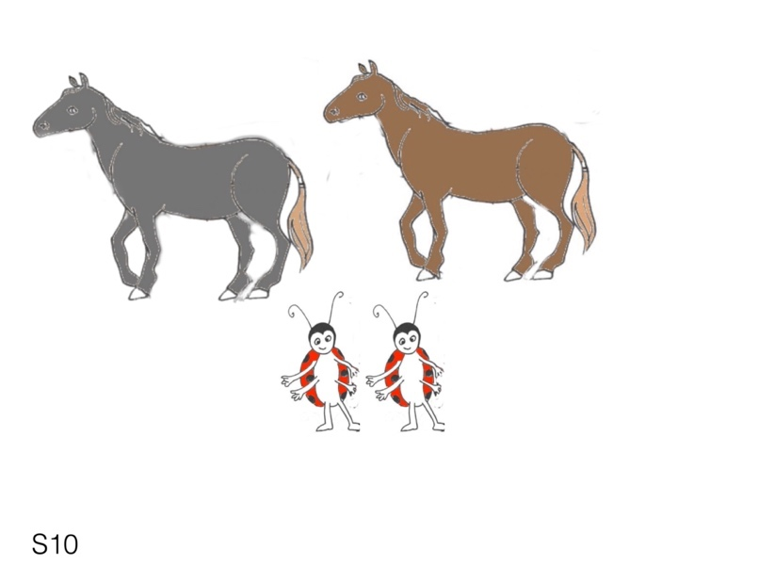
Narrator:
- “There are two ladybugs and two horses, one is grey and the other is brown. Let's see what happens.”
Change picture
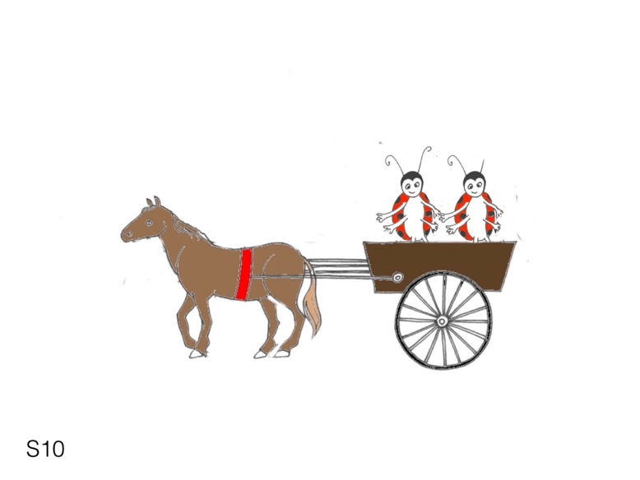(horse covered)
Narrator:
- “One of the horses is pulling the ladybugs. The puppet knows which. Ask the puppet (which).
*CHI: “Which horse is pulling the ladybugs?”
Puppet:
- “The brown horse.”
Reveal the character
Narrator:
- “Good Puffi!”

S11
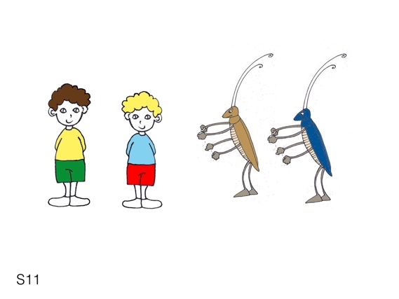
Narrator:
- “There are two boys and two grasshoppers, one is brown and the other is blue. Let's see what happens.”
Change picture
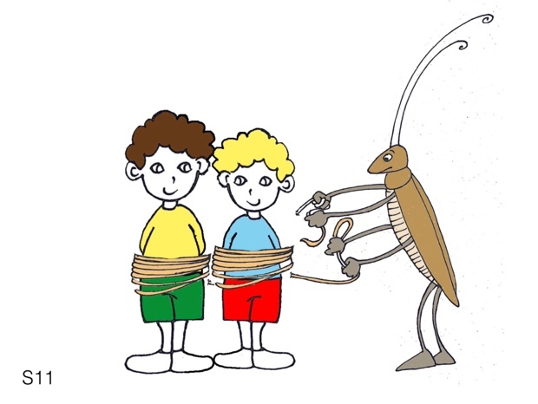(grasshopper covered)
Narrator:
- “One of the grasshoppers is catching the boys. The puppet knows which. Ask the puppet (which).
*CHI: “Which monkey is scratching the ghost?”
Puppet:
- “The brown grasshopper.”
Reveal the character
Narrator:
- “Good Puffi!”

S12
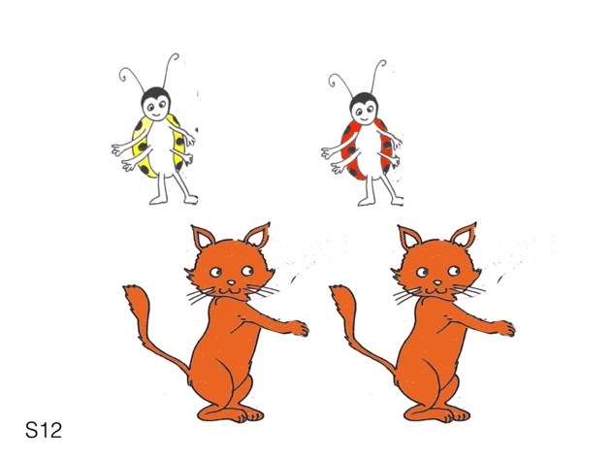
Narrator:
- “There are two cats and two ladybugs, one is yellow and the other is red. Let's see what happens.”
Change picture
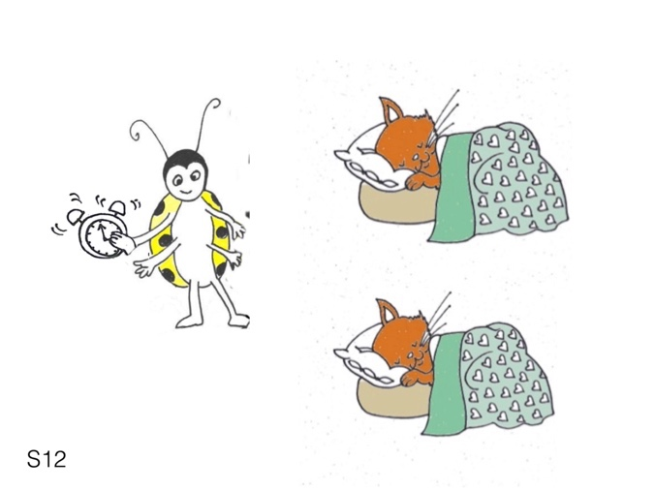(ladybug covered)
Narrator:
- “One of the ladybugs is waking up the cats. The puppet knows which. Ask the puppet (which).
*CHI: “Which ladybug is waking up the cats?”
Puppet:
- “The yellow ladybug.”
Reveal the character
Narrator:
- “Good Puffi!”

O7
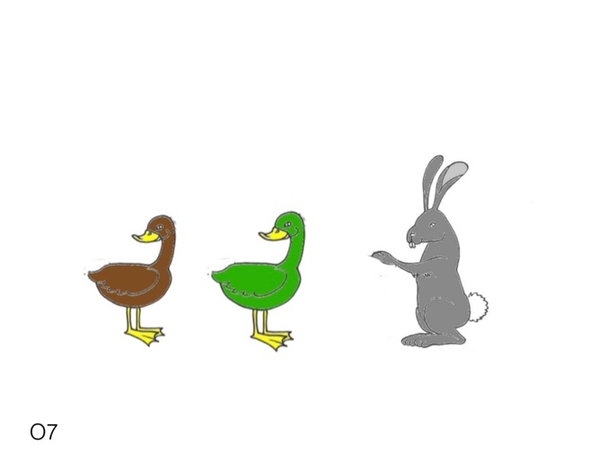
Narrator:
- “There is a rabbit and two ducks, one is brown and the other is green. Let's see what happens.”
Change picture
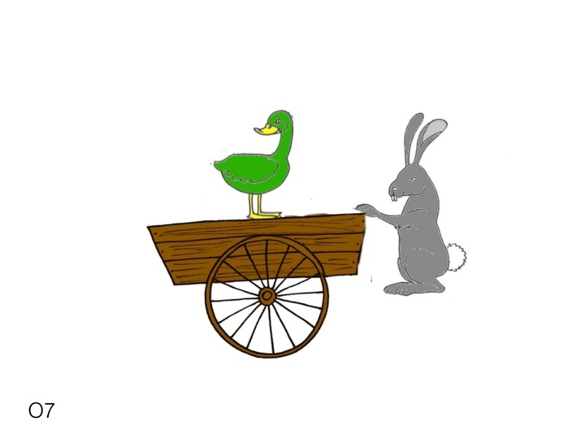(duck covered)
Narrator:
- “The rabbit is pushing one of the ducks. The puppet knows which. Ask the puppet (which).
*CHI: “Which duck is the rabbit pushing?”
Puppet:
- “The green duck.”
Reveal the character
Narrator:
- “Good Puffi!”

O8
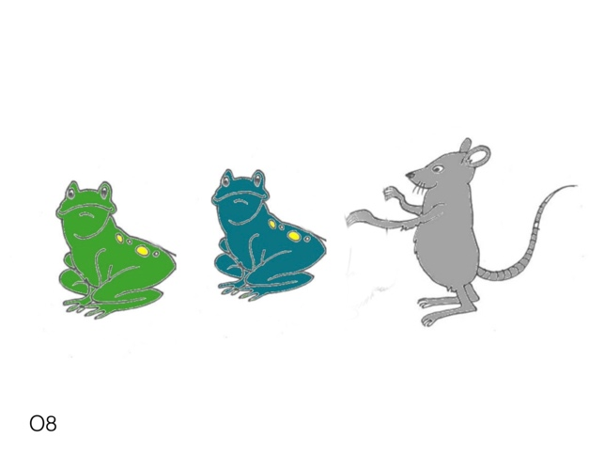
Narrator:
- “There is a mouse and two frogs, one is green and the other is blue. Let's see what happens.”
Change picture
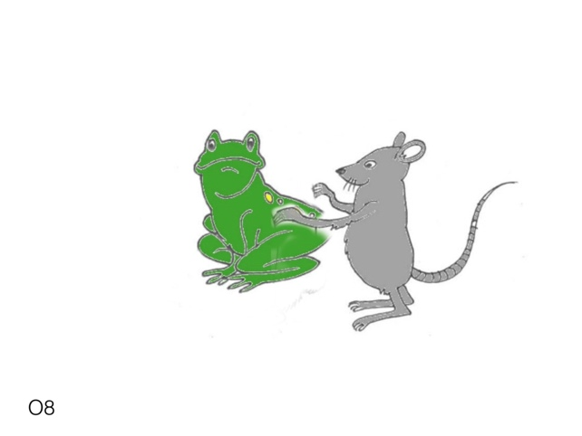(frog covered)
Narrator:
- “The mouse is scratching one of the frogs. The puppet knows which. Ask the puppet (which).
*CHI: “Which frog is the mouse scratching?”
Puppet:
- “The green frog.”
Reveal the character
Narrator:
- “Good Puffi!”

O9
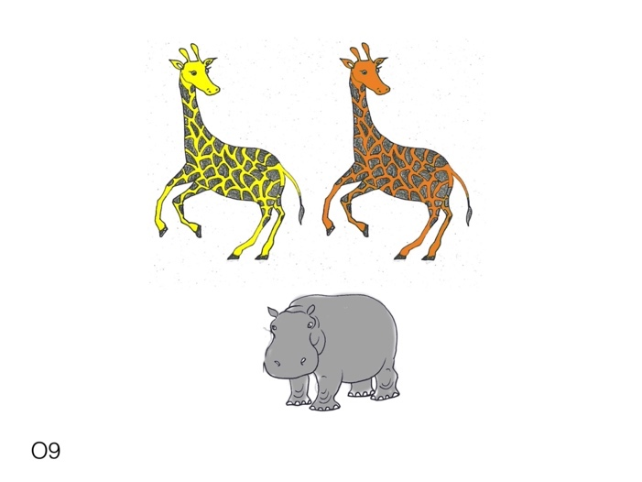
Narrator:
- “There is a hippo and two giraffes, one is yellow and the other is orange. Let's see what happens.”
Change picture
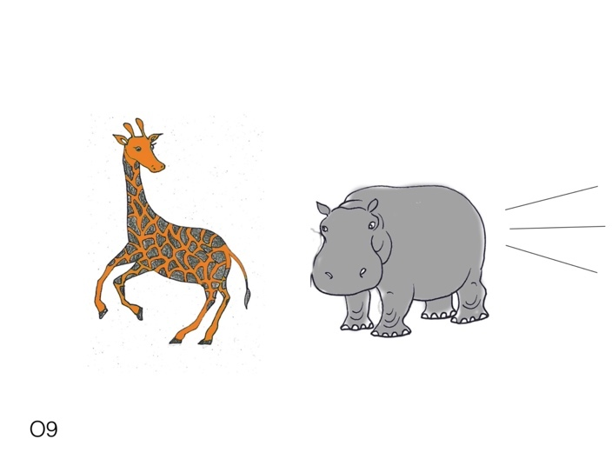(giraffe covered)
Narrator:
- “The hippo is chasing one of the giraffes. The puppet knows which. Ask the puppet (which).
*CHI: “Which giraffe is the hippo chasing?”
Puppet:
- “The orange giraffe.”
Reveal the character
Narrator:
- “Good Puffi!”

O10
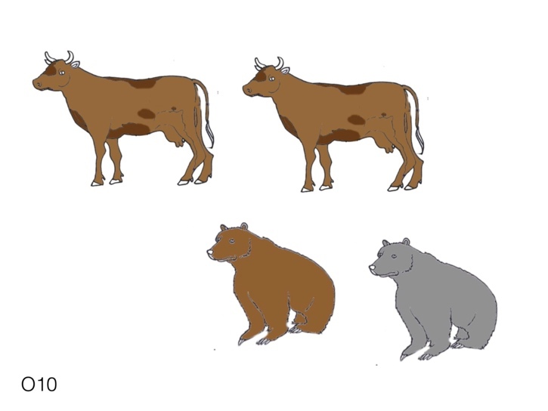
Narrator:
- “There are two cows and two bears, one is brown and the other is grey. Let's see what happens.”
Change picture
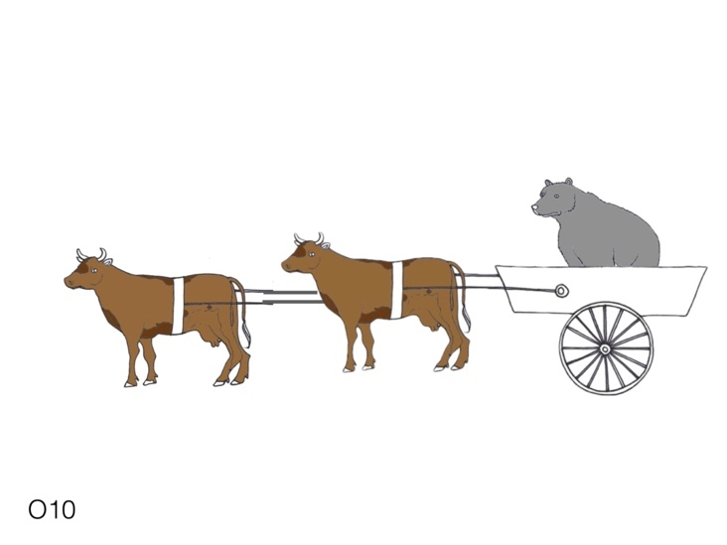(bear covered)
Narrator:
- “The cows are pulling one of the bears. The puppet knows which. Ask the puppet (which).
*CHI: “Which bear is the cows pulling?”
Puppet:
- “The grey bear.”
Reveal the character
Narrator:
- “Good Puffi!”

O11
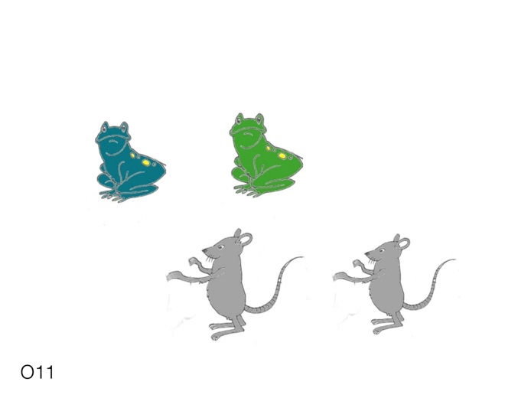
Narrator:
- “There are two mice and two frogs, one is blue and the other is green. Let's see what happens.”
Change picture
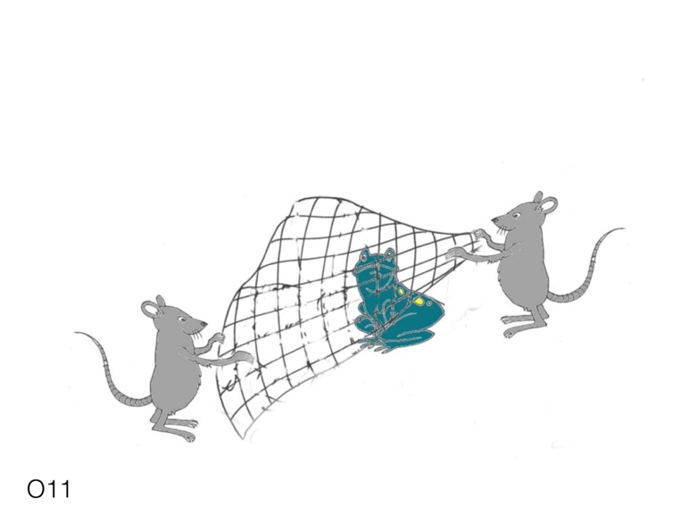(frog covered)
Narrator:
- “The mice are catching one of the frogs. The puppet knows which. Ask the puppet (which).
*CHI: “Which frog is the mice catching?”
Puppet:
- “The blue frog.”
Reveal the character
Narrator:
- “Good Puffi!”

O12
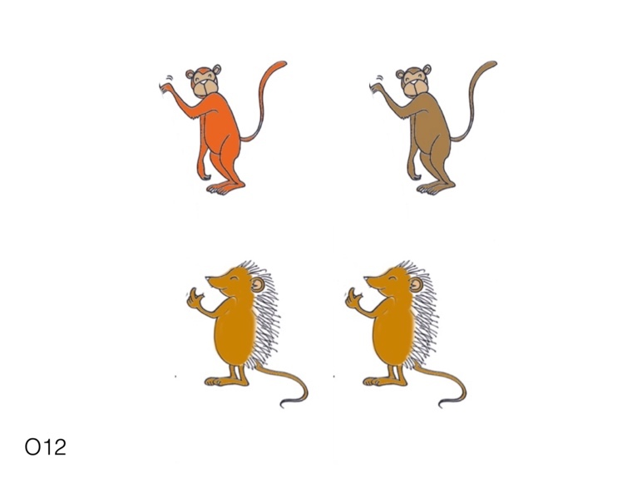
Narrator:
- “There are two hedgehogs and two monkeys, one is orange and the other is brown. Let's see what happens.”
Change picture
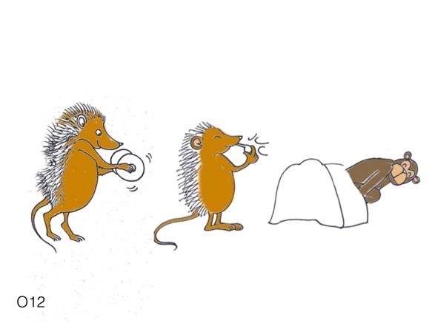(monkey covered)
Narrator:
- “The hedgehogs are waking up one of the monkeys. The puppet knows which. Ask the puppet (which).
*CHI: “Which monkey are the hedgehogs waking up?”
Puppet:
- “The brown monkey.”
Reveal the character
Narrator:
- “Good Puffi!”

FEEDBACK OF THE EXPERIMENTER FOR THE WARM-UP PHASE:
- The child ask just who
The puppet canno understand. Can you ask more?
- No response, Refuse to ask or ”I don’t know” :
Let’s see if XXX really knows everything. Ask him
- If the child produces a question but changes the verb/noun/tense/aspect: no feedback, we can go on.
- After you have tried two other feedback to help the child, and the child still does not produce a question, try the following, but only in the training phase:
Can you repeat my question to the puppet
Who is wtting the sailor?

- If teh child after option 5 cannot produce a question or does not repeat the question
- Ask the child “do you want to stop?”
- if yes: praise the child “Great job!”
- if no: do some more trial until the exit point implemented in the Labvanced (one after the training phase and one after each item in the experimental phase)
- if during the warm up phase the child has produced no RC, but says that he wants to do some more trials, do three more trials. If still no wh-sentence is produced, praise the child and stop. You may say to the child that Puffi is tired and needs to rest. If at least two of these trials are a RC go on. But if the child produces no wh-sentence, stop as soon as possible. It would be a pain for the child to continue if the production of RC is sporadic.

FEEDBACK OF THE EXPERIMENTER FOR THE experimental PHASE:
- The child ask just who
The puppet canno understand. Can you ask more?
- No response, Refuse to ask or ”I don’t know” :
Let’s see if XXX really knows everything. Ask him
- If the child produces a question but changes the verb/noun/tense/aspect: no feedback, we can go on.

